CYBERSECURITY INCIDENT ANALYSIS
Organization: Olashore School
Website: www.olashoreschool.com
IP Address: 64.29.17.1
Date Tested: 9/2/2026
Prepared By: Cyber Knight One

TEAM MEMBER NAMES
HAASTRUP A. DAVID
OYEDEPO AKOREDE
ADENIYI PRECIOUS
ILUGBIYIN EMMANUEL
AGBAJE SEUNFUNMI
OGUNLEYE PRAISE
KARONWI OLUWANIFEMI

TABLE OF CONTENT
- Vulnerability Title
- Target Information
- Vulnerability Description
- Evidence
- Risk/Impact
- Severity Assessment
- Recommendation/Remediation
- Conclusion

OPEN NETWORK PORT EXPOSING THE ASSET TO DoS ATTACKS
Victim: www.olashoreschool.com
IP Address: 64.29.17.1

VULNERABILITY DESCRIPTION
When we ran a cyber security scan on the website network, we discovered that the HTTP port (80) is open to denial of service (DoS) which can also lead to DDoS (distributed denial of service) by threat actors commonly know as hackers
DEFINITION OF DoS ATTACK
A Denial-of-Service (DoS) attack is a cybersecurity attack in which an attacker deliberately overwhelms a website, server, or network resource with excessive requests or traffic, causing it to become slow, unstable, or unavailable to legitimate users. The primary objective of a DoS attack is to disrupt the availability of the targeted service.

EVIDENCE PRESENTATION
Evidence 1: Target information
Website Tested: www.olashoreschool.com
IP Address: 64.29.17.1
Date: 9/2/2026

Evidence 2: Technical Observation
Check out the details on the next page
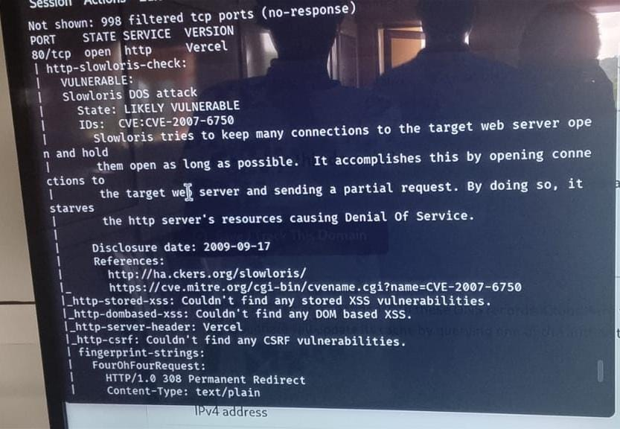
This is the evidence of the vulnerability detected

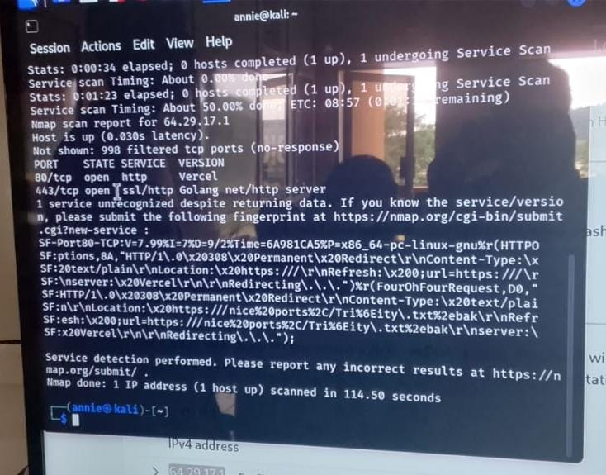

These are the software versions that the website is running. Here, we have Vercel that the http service runs on while Golang runs https service which is the encrypted service.

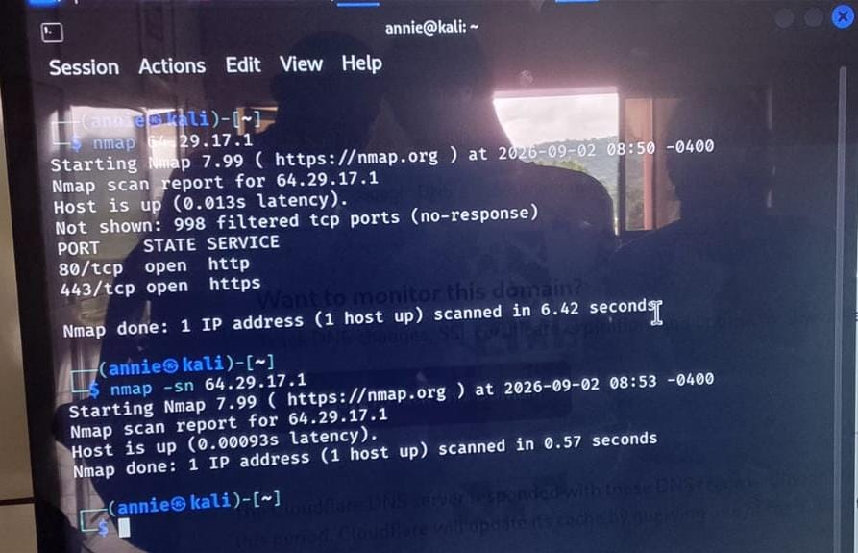
TOP: These are the vulnerable ports that are opened
BOTTOM: These are the Nmap scan results showing the publicly accessible services identified during the security assessment.

RISK/IMPACT

A successful Denial-of-Service (DoS) attack could overwhelm the school's web server and prevent legitimate users from accessing the website. This may affect students, parents, staff, and other visitors who rely on the website for school information and online service

The potential impacts include:
- Temporary unavailability of the school website.
- Slow website performance and service disruption.
- Inability of legitimate users to access important school information.
- Loss of productivity for staff and users.
- Possible reputation damage to the school.
- Additional costs associated with investigating and recovering from the disruption.

Severity assessment
Severity Level: Medium
The identified Denial-of-Service (DoS) risk is classified as Medium because a successful attack could affect the availability of the school's website and prevent legitimate users from accessing it. However, the assessment did not intentionally disrupt or overload the website, so the actual extent of the impact has not been confirmed.
The risk can be reduced through appropriate network security controls, traffic monitoring, rate limiting, firewall configuration, and the use of DoS/DDoS protection services.

RECOMMENDATION AND REMEDIATION

To reduce the risk of a Denial-of-Service (DoS) attack and improve the availability of the school's website, the following measures are recommended:
- Deploy DoS/DDoS protection
Use a reputable DDoS protection service or web application firewall (WAF) to detect and filter malicious traffic before it reaches the web server.
- Configure firewall rules
Configure the firewall to restrict unnecessary traffic and allow only required services and ports.
- Implement rate limiting
Limit the number of requests that a single source can send to the website within a specific period.
- Monitor network traffic
Continuously monitor unusual increases in traffic, repeated requests, and other signs of potential attacks.
- Keep the web server updated
Regularly update the operating system, web server, website software, and security components to address known vulnerabilities.
- Review exposed services and ports
Close unnecessary publicly accessible ports and restrict administrative services to authorized users or networks.
- Establish an incident response plan
The school should have a documented procedure for detecting, responding to, and recovering from a DoS/DDoS incident.
Remediation Goal:
The primary objective is to reduce the school's Internet-facing attack surface and ensure that legitimate users can continue accessing the website during periods of abnormal or malicious traffic.

CONCLUSION
The security assessment of Olashore School's website identified a potential Denial-of-Service (DoS) risk that could affect the availability of the school's online services. Although the assessment did not intentionally disrupt or overload the website, the identified risk highlights the importance of protecting Internet-facing systems against service disruption.
Implementing appropriate firewall rules, traffic monitoring, rate limiting, regular security updates, and DoS/DDoS protection can help reduce the risk and improve the overall security and availability of the school's website.

10

